Name: Muhammad Huzaifa
Roll No: Su92-Bsaim-s24-010
Section: 4A
Subject: AI Lab Task

Task 6 DOCUMENTATION:
Face Profiling Web App (Using Flask & MediaPipe)
Objective:
The main goal of this task is to create a Flask-based web application that can detect and analyze a person’s face using the MediaPipe Face Mesh model.
The app allows users to upload an image, and it automatically detects facial landmarks to generate a visual output and a simple personality message.

Tools and Technologies Used:
- Python – Programming language
- Flask – Web framework for backend
- OpenCV (cv2) – For reading and processing images
- MediaPipe – For face detection and landmark mapping
- HTML – For creating a simple web interface

Folder Structure:
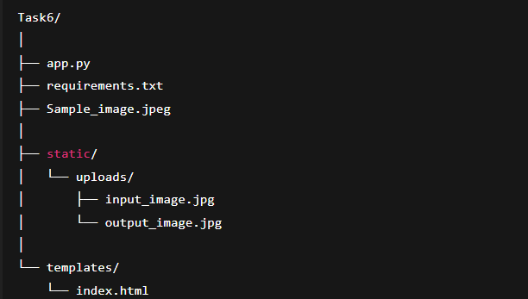
Working Steps:
- Run Flask App:
The app starts using the command → python app.py
- Open in Browser:
It opens on http://127.0.0.1:5000
A simple web page appears with an image upload form.
- Upload an Image:
The user selects a face image and uploads it.
- Face Detection:
Flask reads the image and sends it to MediaPipe,
which detects the face and draws facial landmarks (eyes, nose, lips, etc.).
- Output Display:
The processed image is saved in the folder static/uploads/
and displayed on the browser along with a personality message.

Output:
After uploading an image:
- You see the face with blue landmark lines on it.
- A message appears such as:
“You seem confident and positive-minded! ”

Results:
- Successfully detected and visualized facial features.
- Web app works smoothly with image upload and display.
- Gave personality feedback based on face detection.

Conclusion:
This task helped in learning how to:
- Build a web app using Flask.
- Use MediaPipe for face detection.
- Handle image upload and display on a web interface.
It combined computer vision and web development into one practical project.

